

International School

**Capstone Project 1**

CMU-SE 450/CMU-IS 450/CMU-CS450

**Architecture Document**

**Version 1.0**

**Date: August 20, 2020**

**UNIVERSITY REVIEWS**

**Submitted by**

**Nguyen Van Minh Toi**

**Nguyen Huu Thien**

**Ho Xuan Sang**

**Huynh Thi Quy Thuong**

**Approved by**

**Proposal Review Panel Representative:**

Name Signature Date

**Capstone Project 1- Mentor:**

Name Signature Date

Dr.Ha Thi Nhu Hang

**PROJECT INFORMATION**

|  |  |  |  |
| --- | --- | --- | --- |
| Project acronym | URs | | |
| Project Title | University reviews | | |
| Start Date | August 13, 2020 | End Date | December 05, 2020 |
| Lead Institution | International School, Duy Tan University | | |
| Project Mentor &contact details | Dr. Ha Thi Nhu Hang  Email: [hatnhuhang@duytan.edu.vn](mailto:hatnhuhang@duytan.edu.vn)  Tel: 0707121301 | | |
| Product Owner | Toi, Nguyen Van Minh  Email: [minhtoi2799@gmail.com](mailto:minhtoi2799@gmail.com)  Tel: 0902257132 | | |
| Scrum Master | Thien, Nguyen Huu  Email: [huuthiennguyen1999@gmail.com](mailto:huuthiennguyen1999@gmail.com)  Tel: 0783533812 | | |
| Team members | Name | Email | Tel |
| Toi, Nguyen Van Minh | minhtoi2799@gmail.com | 0902257132 |
| Thien, Nguyen Huu | huuthiennguyen1999@gmail.com | 0783533812 |
| Sang, Ho Xuan | hsang19999@gmail.com | 0362982905 |
|  | Thuong, Huynh Thi Quy | quythuong0405@gmail.com | 0333633770 |

|  |  |  |  |
| --- | --- | --- | --- |
| **DOCUMENT NAME** | | | |
| **Document Title** | Architecture Document | | |
| **Author(s)** | C1SE.04 Team | | |
| **Role** | Thuong, Huynh Thi Quy | | |
| **Date** | August 20, 2020 | **File name:** | Architectture v1.0 |
| **URL** |  | | |
| **Access** |  | | |

REVISION HISTORY

| **Version** | **Date** | **Comments** | **Author** | **Approval** |
| --- | --- | --- | --- | --- |
| 1.0 | August 20, 2020 | Initial Release | Thuong, Huynh Thi Quy |  |

|  |  |  |  |
| --- | --- | --- | --- |
| **Document Approval**  The following signatures are required for approval of this document | | | |
| **Mentor** | Dr. Ha Thi Nhu Hang | **Signature:** |  |
| **Date:** |  |
| **Signature:** |  |
| **Date:** |  |
| **Scrum Master** | Nguyen Huu Thien | **Signature:** |  |
| **Date:** |  |
| **Team Member(s)** | Nguyen Van Minh Toi | **Signature:** |  |
| **Date:** |  |
| Huynh Thi Quy Thuong | **Signature:** |  |
| **Date:** |  |
| Ho Xuan Sang | **Signature:** |  |
| **Date:** |  |

**Table of contents**

**1.** **Introduction** 5

***1.1.*** ***Overview Document*** 5

***1.2.*** ***Documents References*** 5

**2.** **Project Statement** 5

***2.1.*** ***Project Overview*** 5

**2.2.** **Business Driver** 5

***2.2.1.*** ***Business Problems :*** 5

***2.2.2.*** ***Business Need:*** 6

***2.2.3.*** ***Project Goals*** 6

**3.** **Architecture Driver** 6

***3.1.*** ***High-Level Requirements:*** 6

***3.2.*** ***System Context*** 6

**3.3.** **Non-functional properties** 7

***3.3.1.*** ***Availability*** 7

***3.3.2.*** ***Usability*** 7

***3.3.3.*** ***Performance*** 7

***3.3.4.*** ***Security*** 8

**4.** **Constraint** 8

***4.1.*** ***Constraint on manpower and time*** 8

***4.2.*** ***Technical Constraint*** 8

**5.** **High Level Architecture** 9

***5.1.*** ***Component and Connection view cho Web (C&C view for web)*** 9

***5.2.*** ***Allocation View*** 10

1. **Introduction**
   1. ***Overview Document***

This specification covers following:

* Brief specification of the project, high level requirement, system context for the system.
* Use case diagram, detail quality attribution.
* Architecture presented by various architecture view types: Component and Connect tor view, Module view, Allocation view.
  1. ***Documents References***

|  |  |
| --- | --- |
| No | Documents References |
| 01 | [URs] Product Backlog_v1.1 |
| 02 | [URs] Project Plan_v1.0 |

Table 1: Document References

1. **Project Statement**
   1. ***Project Overview***
   * Project name: University Reviews - URs
   * Development team:

|  |  |
| --- | --- |
| Full name | Position |
| Nguyen Van Minh Toi | Product Owner |
| Nguyen Huu Thien | Master Scrum |
| Huynh Thi Quy Thuong | Member |
| Ho Xuan Sang | Member |

* 1. **Business Driver**
     1. ***Business Problems:***
* As we can see every year the universities hold entrance exams at some high school locations for their 12th-grade students. But this is really inefficient because they can't go. Too many special places in the mountainous areas, it is not possible to pass all information to the students.
* Actually, there are a number of websites that support this demand, but very few and not yet optimized.
  + 1. ***Business Need:***
  + Needs better interaction between job seekers and domestic workers.
  + User should be provided with necessary information about job information.
  + Need high reliability.
  + Optimizing the process of finding and providing jobs.
    1. ***Project Goals***
* The goal of the project is to make the bridge between users and universities easier to provide information and to find information.

1. **Architecture Driver**
   1. ***High - Level Requirements:***

Refer to the document [URs] Product Backlog_v1.1 of University Reviews.

* 1. ***System Context***

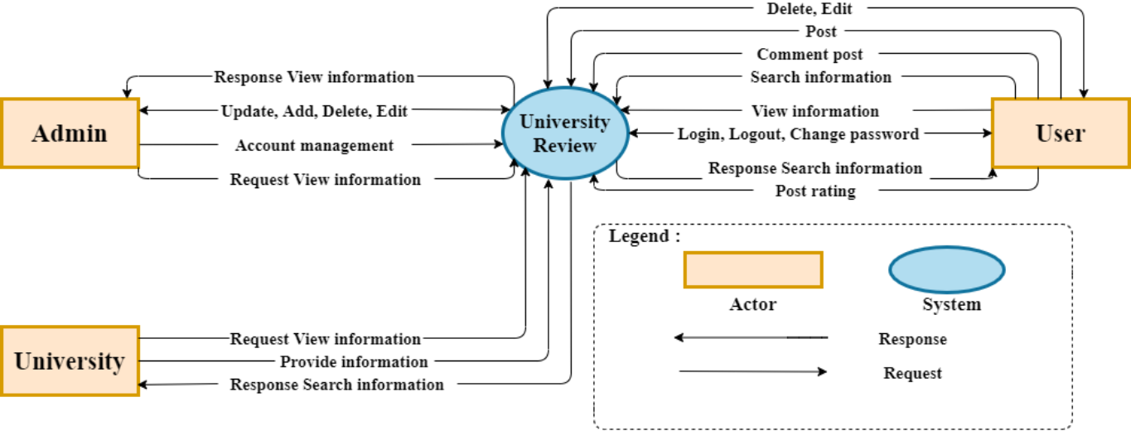

*Figure 1: System context*

* ***Description:***

  −       **Admin** is responsible for system management. They will use the site with the main functions:

* User management
* Account management
* System management
* Manage management
* Search

−       **User** is someone who will use applications with main functions using both web. After completing the functions, users will update information on the system:

* View post
* View information about the University
* See notifications
* Look for information
* Post an article
* School rating
* Write a comment

−       **University** is the person who will use applications with major functions using the web. After completing the functions, users will update information on the system:

* View post
* View comments
* See reviews
* Post an introduction, providing information about the University
  1. **Non-functional properties**
     1. ***Availability***
* The system operates 24/7 smoothly and stably.
  + 1. ***Usability***
* The system has an intuitive interface.
* User is easy to use.
  + 1. ***Performance***
* The system will respond in 3-5 seconds.
  + 1. ***Security***
* The system automatically encrypts passwords and data.

1. **Constraint**
   1. ***Constraint on manpower and time***

o Manpower: 4 people

o The project will be started on August 13, 2020

o The project is scheduled to be completed by December 5, 2020

o The project will be completed in about 4 months

* 1. ***Technical Constraint***
  + **Language:** HTML, CSS, JavaScript, NodeJS
  + **Environment:**

**-** Web browsers: Google Chrome, Opera, Microsoft Edge.

**-**Operating system: Window.

**-** Develop tools: Visual Studio

**-** Database: MongoDB, CMS Keystone

**-** Internet Connection

1. **High Level Architecture**
   1. ***Component and Connection of Web (C&C view for web)***

The diagram below shows the overview architecture including components and other related components.

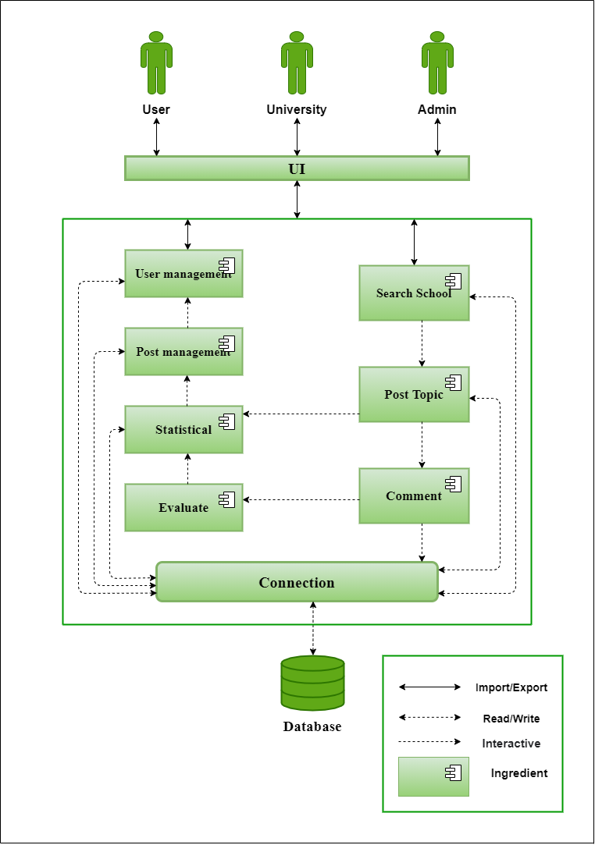

*Figure 2*: Architectural diagrams

***Description****:*

* + The web application runs on some browsers such as Google Chrome, Opera, Microsoft Edge.
  + Interactions in the system: Represents interactions between the components in the system.
  + Applications will receive requests from users through support service methods to receive data and display it to the user.
  + Request and reply when a user makes a request. The system will interact with the database to process business logic and give feedback to users.
  1. ***Allocation View***



*Figure 3*: Allocation View